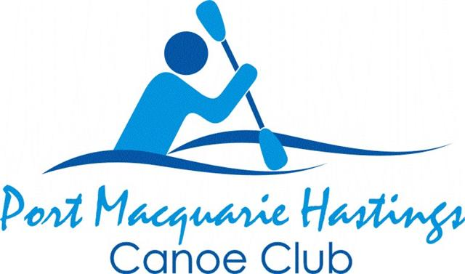
November, December, January 2026/27
SCHEDULE

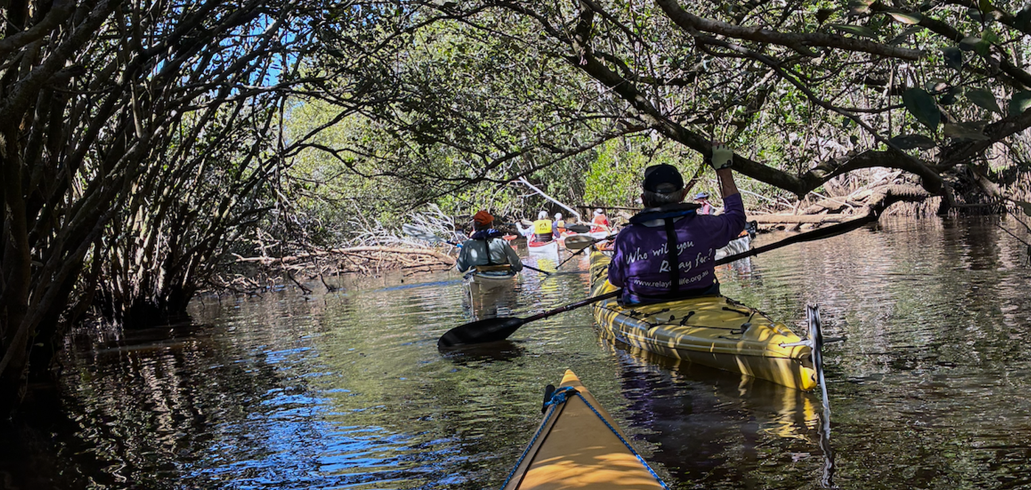
Torrens Anabranch. (Photo: M Dickins)

IT IS THE POLICY OF THE PORT MACQUARIE HASTINGS CANOE CLUB INC (PMHCC) THAT LIFE JACKETS (PFD’S) BE WORN WHILST PARTICIPATING IN ALL CLUB PADDLES

REGULAR PADDLES
Every TUESDAY  Turtles social paddle  Fast & furious Group | 7:45am start OTW at McInherney Park boat ramp near the Sailing Club.  Regular hard training run. Mostly skis and racing kayaks. Rated 2/3 Approximately 16kms.  From Marine Rescue Building in Buller St. Paddle up Hastings River to Maria River and return.  Early start. Coffee after at Seasalt Cafe near the Marina in Park Street. | Contact Julie 0421 449519  Contact Bill W 0418 437957
Every THURSDAY  Regular social paddle  Hastings River  Longer Paddle | 6 to 10km options from Westport Park boat ramp. 7:50am briefing then 8:00am OTW.  Cuppa after at Sea Salt  Earlier start & different distance for longer paddle.  Morning tea/coffee after | For shorter paddle contact Stephen  0490 842005  Longer paddle Contact Bill W on 0418 437957

SUNDAY PADDLES
Please message the paddle leader/contact if you are intending to join (or withdraw from) a Sunday paddle. If running late please phone the paddle leader/contact.
Weather conditions etc can result in paddles being changed or cancelled. If you have not registered, you will not be aware of any such changes.

Date | Description | Launch Point | Leader/Contact
Nov 1 | Lake Cathie and/or Lake Inness  8km Rating 1  Morning tea/coffee after Lake Cathie. | Perch Hole  8:30 OTW | Carolyn  0438 462856
Nov 8 | Googlies Lagoon  6-8 Km Rating 1  Morning tea at Dunbogan Boat Shed | Marine Rescue -Laurieton (end Tunis St)  OTW 8:30 | Barry K  0429 028652
Nov 15 | Belmore River  8-10km. Rating 1  Lunch at Smithtown Pub | Smithtown Boat Ramp (next to pub)  OTW 9:00 | Leon  0401 037469
Nov 22 | Logans Crossing  8-10km Rating 1  Picnic lunch at nearby park | Kendal Boat Ramp  OTW 9:00am | Bill V 0439 017810
Nov 29 | Landsdown River towards Cattai Wetlands  8-10km Rating 1  Lunch at Coopernook Pub | Coopernook Pub  OTW 9:00am | Carolyn  0438 462856
Dec 6 | Rocks Ferry towards Bain Bridge  10km Rating 1  Coffee after at Ricardos | Rocks Ferry  OTW 9:00am | Barry K  0429 028652
Dec 13 | Spencers Creek SW Rocks to Jerseyville  14km Rating 2  Lunch at Riverside Tavern | Hacks Ferry boat ramp  OTW 9:15 | Greg  0428 980264
Dec 20 | Herons Creek  12km Rating 2  Picnic lunch after at Queens Lake Sailing Club reserve | Sailing Club - Queens Lake Reserve  OTW 9:00am | Bruce 0438 839387
Dec 31 | New Years Eve Night Paddle. 9:00pm Fireworks  8:15pm OTW | Westport Boat Ramp | Greg  0428 980264
Jan 3 | Greenhills to Belgrave Falls  12-14km Rating 2  Picnic lunch after at | Greenhills Reserve  OTW 8:45am | Stephen  0490 842005
Jan 10 | Queens Lake & Stingray Crk  8-10km Rating 1  Picnic lunch after at Queens Lake Sailing Club reserve | Sailing club Queens Lake  OTW 8:45am | Bill V 0439 017810
Jan 17 | Wilson River - Upstream  10km Rating 1  Picnic after at launch point | Log Wharf Tele Pt  OTW 9:00am | Bruce 0438 839 387
Jan 24 | Watson Taylor Lake  12km. Rating 2  Picnic lunch after at Apex Reserve | Apex Park Dunbogan  OTW 9:00am | Barry W  0438 319767
Jan 31 | Canals  7-8km Rating 1  Sausage Sizzle after | McInherney Park  OTW 8:30am | Julie 0421 449519

Remember to message the paddle leader/contact by the FRIDAY evening before if you are intending to join, if possible. You can always cancel out later if necessary.

VISITORS
Visitors are always welcome…. However, If you wish to bring a friend/new paddler along on any Sunday paddle, please discuss with Carolyn, our Sunday Trip Coordinator, on 0438462856.

OR if bringing a friend/new paddler to a weekly paddle please contact Julie, Stephen,
(As per the Regular Paddles section above)

Not all paddles suit infrequent/new paddlers.


Please bring plenty of drinking water, wear sunscreen & appropriate clothing, a hat & sunglasses etc.

RATING SYSTEM FOR CLUB PADDLES

RATING 1: Up to 10 kms with rests along the way.

RATING 2: 10 – 20 kms Fairly continuous paddling with short breaks; possibility of difficult
conditions or long stretches on open water.

RATING 3: 20+ kms Continuous paddling; extended time in the kayak; possibility of difficult
conditions such as wind & open stretches of water.

RATING 4: 30+ kms Continuous paddling; long stretches in the kayak; likelihood of difficult
conditions & open stretches of water.

Thank you to the touring subcommittee & trip leaders. Please support them as they enable us to be out on the water as frequently as we are.

SAFE PADDLING EVERYONE

