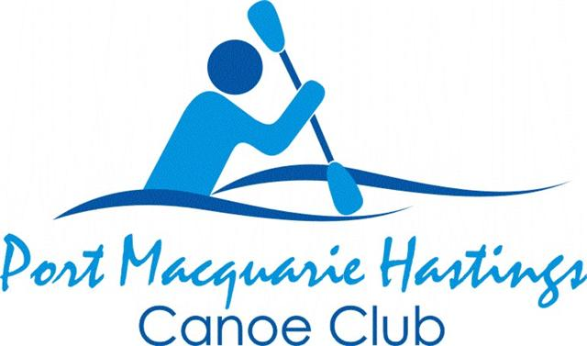
November, December January 2025/26 SCHEDULE
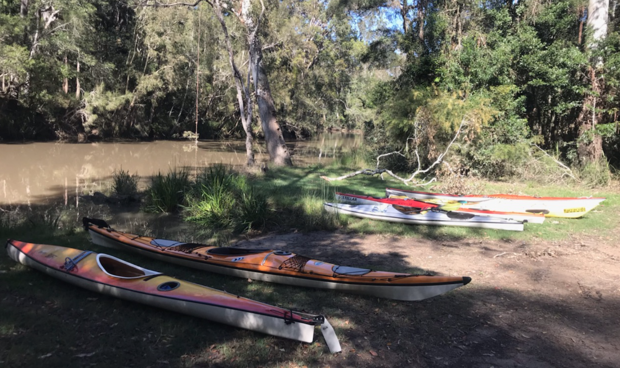
Pipers Creek Kundabung

IT IS THE POLICY OF THE PORT MACQUARIE HASTINGS CANOE CLUB INC (PMHCC) THAT LIFE JACKETS (PFD’S) BE WORN WHILST PARTICIPATING IN ALL CLUB PADDLES

REGULAR PADDLES
Every TUESDAY  Turtles social paddle  OR  Harder training run  Hastings River | 7:45am start OTW at McInherney Park boat ramp near the Sailing Club.  Harder training run: early start from Marine Rescue Building, Buller St. near The Westport Club | Contact Julie  0421 449 519.  For harder paddle contact Bill W 0418437957
Every THURSDAY  Regular social paddle  Hastings River | 6 to 10km options from Westport Park boat ramp.  7:40am briefing then 7:45am OTW.  Earlier start & different distance for longer paddle .  Morning tea/coffee after | For shorter paddle contact Stephen  0490842005  For longer paddle contact Bill W  0418 437 957
Every SATURDAY  Time Trials | 7:30am start OTW at McInherney Park boat ramp near Sailing Club.  Approx 1 hour of paddling aimed at boosting your fitness and perhaps a challenge. Advice on technique available. No competition.  Boost your fitness and challenge yourself.  Cuppa after at Banks Café. | Contact  0413 923043 (Bill W) or  0418 437 957 (Caroline)

SUNDAY PADDLES
Please message the paddle leader/contact if you are intending to join (or withdraw from) a Sunday paddle. If running late please phone the paddle leader/contact.
Weather conditions etc can result in paddles being changed or cancelled. If you have not registered, you will not be aware of any such changes.

Date | Description | Launch Point | Leader/Contact
November 2 | Greenhills to Belgrave Falls  Approx 12-14km Rating 2  Picnic after at launch point | Greenhills Reserve  OTW 9:00am | Stephen  0490842005
November 9 | Stingray Crk  Approx 8-10km Rating 1  Picnic after at launch point | Stingray Crk bridge ramp  OTW 9:30am | Bill V  0439017810
November 16 | Blackmans Pt to The Hatch & lagoon  Approx 10-12km Rating 1-2  Coffee & cake at Ricardos | Blackmans Pt (TBC)  OTW 8:30am | Carolyn  0438462856
November 23 | Fernbank Creek  Approx 8km Rating 1  Coffee at Rivermark Cafe | Fernbank Creek boat ramp  OTW 9:30am | Barry K  0429028652
November 30 | Kendal to Rossglen  Approx 12km Rating 1-2  Picnic after at nearby park | Kemdal Boat Ramp  OTW 8:30am | Bruce  0438839387
December 7 | Spencers Creek SWRocks.  Approx 12km Rating 1-2  Lunch at Riverside Tavern | Matty’s Flat Boat Ramp SWRocks  OTW 9:00am | Greg  0428980264
December 14 | McMillian Drive to Haydens Creek  Approx 8-10km Rating 1-2  Picnic after at launch point | McMillan Drv  OTW 8:30am | Leon  0401037469
December 21 | Yarrahappini Wetlands  Approx 10km Rating 1  Lunch at Riverview Pub, Smithtown | Clybucca Crk  OTW 9:30am | Stephen  0490842005
December 31  Wed Night | New Years Eve Fireworks Paddle Short paddle Rating 1 | Westport Park  OTW 8:30PM | Greg  0428980264
January 4 | Herons Creek  Approx 8-10km. Rating 1  Picnic after at launch point | Via Bobs Creek Rd  (TBC)  OTW 9:00am | Greg  0428980264
January 11 | Rocks Ferry to Sarahs Creek  Approx 8-9 km Rating 1  Picnic after at nearby park | Rocks Ferry Boat Ramp  OTW 8:45am | Barry W  0438319767
January 18 | McMillan Drive to Rawdon Creek  Approx 12km Rating 2  Coffee & cake at Ricardos | McMillan Drive  OTW 9:00am | Barry K  0429028652
January 25 | McInherney Park to Settlement Pt  Approx 7-8km Rating 1-2  + Sausage Sizzle ($2) at park | McInherney Park  OTW 8:30am | Julie  0421449519

Remember to message the paddle leader/contact by the FRIDAY evening before if you are intending to join, if possible.
You can always cancel out later if necessary.

If you wish to bring a friend/new paddler along on any Sunday paddle, please discuss with Carolyn, our Touring Coordinator, on 0438462856.

OR if bringing a friend/new paddler to a weekly paddle please contact Julie, Stephen, Bill or Caroline (As per the Regular Paddles section above)

Not all paddles suit infrequent/new paddlers.


Please bring plenty of drinking water, wear sunscreen & appropriate clothing, a hat & sunglasses etc.

RATING SYSTEM FOR CLUB PADDLES

RATING 1: up to 10 kms with rests along the way
RATING 2: 10 – 20 kms fairly continuous paddling with short breaks; possibility of difficult
Conditions or long stretches on open water.
RATING 3: 20+ kms continuous paddling; extended time in the kayak; possibility of difficult
conditions such as wind & open stretches of water
RATING 4: 30+ kms continuous paddling; long stretches in the kayak; likelihood of difficult
conditions & open stretches of water

Thank you to the touring sub committee & trip leaders. Please support them as they enable us to be out on the water as frequently as we are.

SAFE PADDLING EVERYONE

