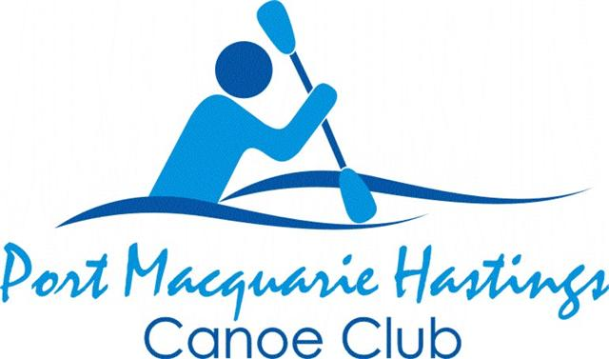
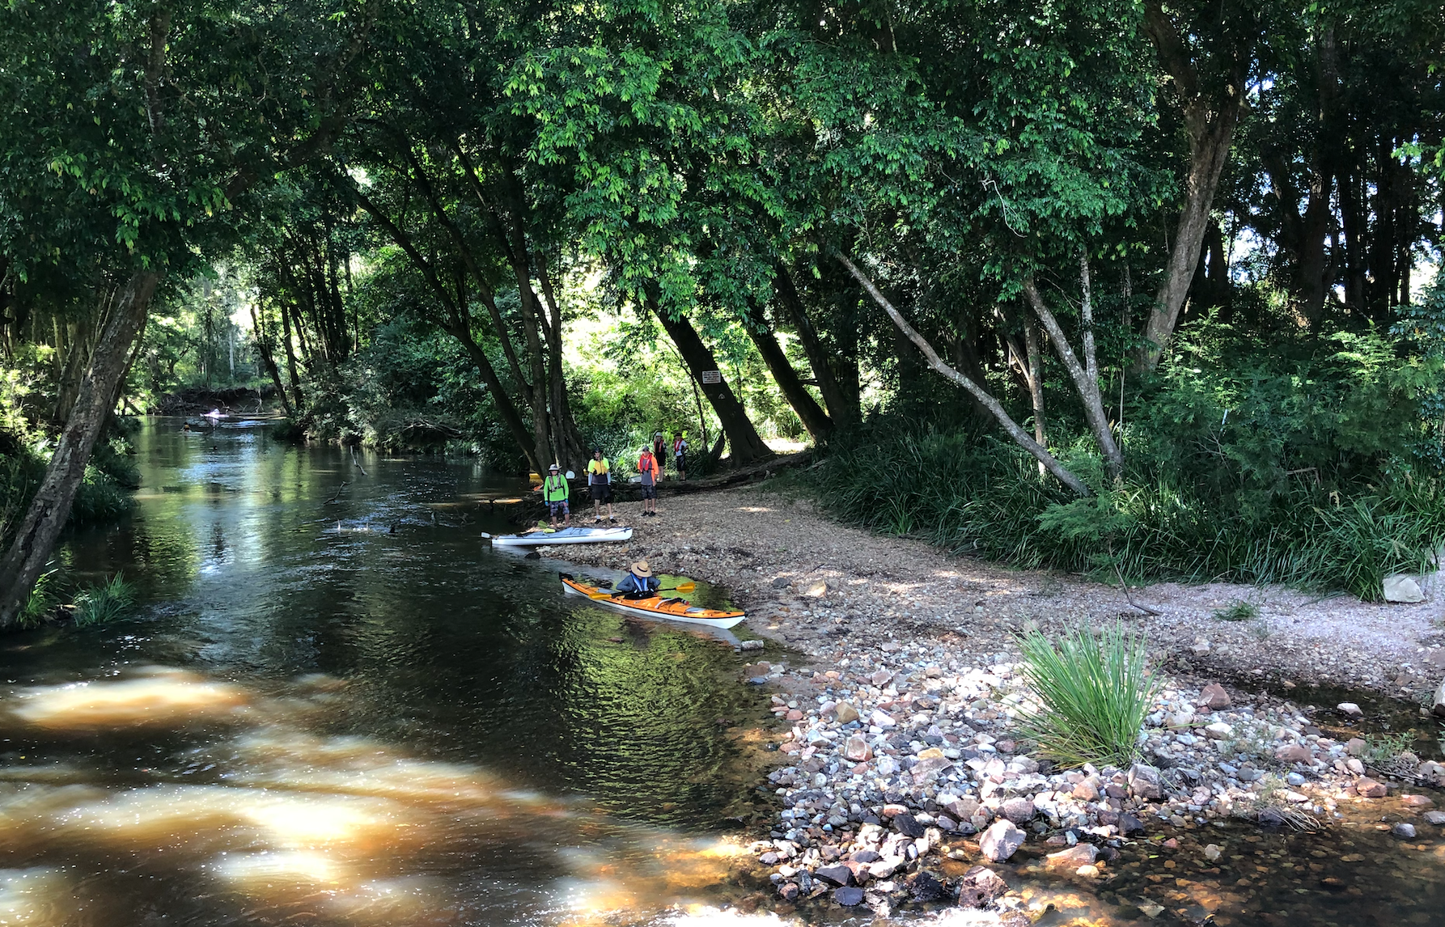
Logans Crossing, Camden Haven River

Are you active, and looking for a sporting and recreational outlet?

Port Macquarie Hastings Canoe Club Inc was established in 2007. We are a sporting and social outlet with a welcoming group of people. The club caters for both fitness and recreational paddling here in Port Macquarie and other nearby waterways, providing different paddling opportunities Tuesdays, Thursdays and over the weekend.
Our social paddling is best suited to those with touring kayaks, whilst our members more focused on fitness paddles, tend to paddle faster flatwater boats and surf skis.
Kayaks can be made available for newcomers wanting to try paddling and we can provide assistance with paddling technique and safety/rescue training.
So, if you are interested in improving your fitness on the water, or recreational and social paddling, for more information, please contact:

Contact: Barry K - Club President Email: portkayaking@gmail.com

