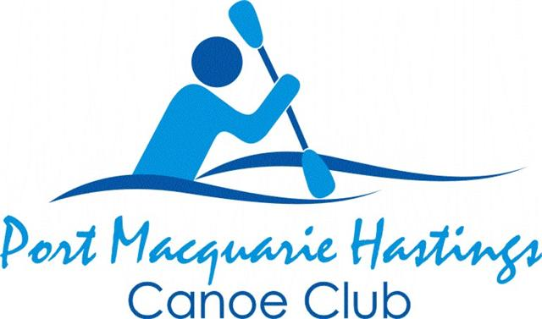
PORT MACQUARIE HASTINGS CANOE CLUB INC
SCHEDULE OF PADDLES
AUGUST, SEPTEMBER, OCTOBER 2020
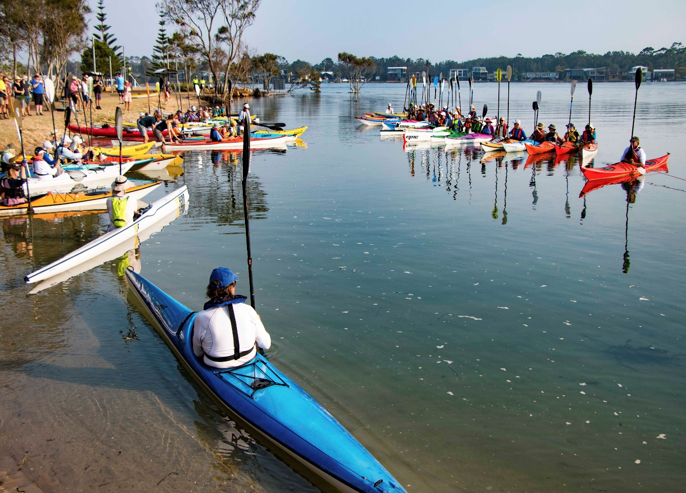
On Thursday 9 January, 2020 over 100 people farewelled Roger Price at Settlement Point in a moving water tribute with a raised paddle salute. He was a foundation member of the PMHCC & served as vice president in 2010.
He will always be remembered & missed greatly.
***** Due to ongoing & changing COVID-19 regulations, this schedule & any gatherings related to listed activities maybe subject to change at short notice. Please contact President Greg Donaldson if unsure on 0428 980 264.
Thank- you. The Committee, Port Macquarie Hastings Canoe Club.
IT IS THE POLICY OF THE PORT MACQUARIE
HASTINGS CANOE CLUB INC (PMHCC) THAT
LIFE JACKETS (PFD’S) BE WORN AT ALL TIMES
WHILE PARTICIPATING IN CLUB PADDLES.

PLEASE NOTIFY THE LEADER OF ANY PADDLE YOU INTEND PARTICIPATING IN AND ADVISE HIM/HER OF YOUR INTENTION TO JOIN THEIR PADDLE;
LIKEWISE SHOULD YOU NEED TO CANCEL OUT.

THIS IS OUR WINTER SCHEDULE OF PADDLES
MAKE SURE YOU REMAIN WELL HYDRATED, WEAR WET WEATHER
PROTECTION CLOTHING IF NECESSARY & TAKE A CHANGE OF DRY
CLOTHES IN CASE OF RAIN DURING THE PADDLE

WE TRY TO SCHEDULE PADDLES FOR EARLY IN THE DAY, TIDES PERMITTING. START TIMES ARE ON THE WATER UNLESS OTHERWISE INDICATED.
THERE WILL BE NO CHARITY RAFFLES UNTIL FURTHER NOTICE
PLEASE ALLOW SUFFICIENT TIME TO UNLOAD YOUR KAYAK & ORGANISE YOURSELF BEFORE THE START OF THE PADDLE. IF THERE IS A LARGE GROUP OF PADDLERS IT TAKES AWHILE TO GET EVERYONE ON TO THE WATER. IF RUNNING LATE OR UNABLE TO PARTICIPATE IN THE PADDLE ON THE DAY, PLEASE TRY TO MAKE PHONE CONTACT WITH THE LEADER & ADVISE HIM/HER ASAP SO THE PADDLE CAN GET UNDERWAY ON TIME.
IF A PADDLE NEEDS TO BE ALTERED/CANCELLED FOR ANY REASON AT SHORT NOTICE, ONLY THOSE MEMBERS WHO HAVE REGISTERED FOR THE PADDLE WILL BE MADE AWARE OF ARRANGEMENTS IN PLACE FOR SUCH CONTINGENCIES.
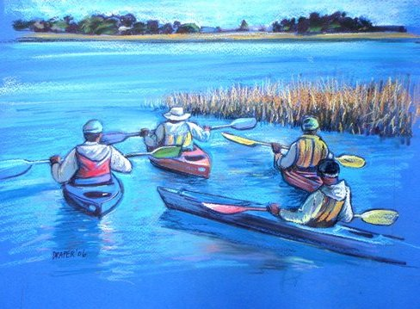
RATING SYSTEM FOR CLUB PADDLES
RATING 1: 10-15 kms: rests along the way
Average rate 5-6 kph
RATING 2: 15-20 kms: fairly continuous paddling with short breaks &/or
Possibility of difficult conditions, open water etc
Average rate 6-7 kph
RATING 3: 20 + kms: fairly continuous paddling for 60 -75 minutes;
Extended time in the kayak & possibility of
Difficult conditions, Eg; open stretches of water
& windy conditions.
Average rate 6 – 9 kph
RATING 4: 30 + kms: Hard paddling long periods in the kayak.Average 10kph

PLEASE REMEMBER SOCIAL DISTANCING REQUIREMENTS WHILST PADDLING
Monday, 3 August   | Moonlight paddle. Rating 1. MUST USE LIGHTS. Rating 1 | Approx. 6 – 8 kms on Hastings River | 5 pm on the water at the Westport Boat Ramp | Contact Greg for details on 0428 980 264 or  gregjdonaldson@bigpond.com
Tuesday, 4,11,18 & 25 August   | Hard, fast training run. Mostly skis & racing kayaks. Rating 3 | 16 kms approx.. from Marine Rescue Bldg. up Hastings River to Maria River & return | Early start. Possible take away coffee after from  Seasalt Cafe | 
Thursday 6,13,20 & 27 August | Social AM paddle.  Ratings 1 & 2 | 6 & 12 kms options on the Hastings River from Sett. Pt. Reserve near big ferry | 7.50am briefing then 8am start on water. Parking, amenity block | Contact Greg Donaldson on 0428 980 264 or email  gregjdonaldson@bigpond.com  **Due to COVID-19 social distancing restrictions, take away coffee can be purchased after the paddle from The Point café & consumed in Settlement Point Reserve in appropriate group sizes
Sunday 9 August | Saltwater Creek at South West Rocks.  Rating 1 | 8 kms approx.. from Surf Club up to & around lagoon | 10am start on water from beach below SW Rocks surf club | Contact Leon Norgate on  0401 037 469 or email  info@birchbb.com  **Contact leader for lunch arrangements
Sunday 16 August | Rocks Ferry to Bain Bridge & Morton Creek  Rating 1/2 | 12 kms approx.. up the Hastings River from Rocks Ferry | 8.30am start from boat ramp at Rocks Ferry Reserve | Contact Barry Kermode on  0429 028 652 or email  barrysaurus@me.com  **Contact leader for morning tea/lunch arrangements
Sunday 23 August | 1.Scotts Creek from Croki to Farquhar Inlet or 2.Around Oxley Island from Croki. Rating 1/2 & 3 | 1. Approx. 12 – 14 kms.  2. Approx. 26 kms | 1. 10 am start from Croki  2. 10 am start  from Croki | Contact Peter for option 1 on  0419 622 790 or email  peterglevy@bigpond.com  ***picnic lunch at Farquhar Inlet & walk along the beach.  For option 2 contact Bill Webber on 0418 437 957 or kayakcas@hotmail.com  
Sunday 30 August | 1.Around Little Rawdon Island or  2. To be decided on the day | Short option approx. 10 kms;  Longer option approx.. 14 kms | 9am start for option 1 from private property on Little Rawdon Island | Contact Greg for option 1 on  0428 980 264 or email  gregjdonaldson@bigpond.com  Contact Bill or Caroline on  0418 437 957 or email  kayakcas@hotmail.com for details of option 2.  ***picnic lunch back on Little Rawdon Island  
Tuesday 1 Sept.   | Moonlight paddle. Rating 1  MUST USE LIGHTS | Approx. 6 – 8 kms on Hastings River | 5 pm on water at Westport Boat Ramp | Contact Greg for details on  0428 980 264 or email  gregjdonaldson@bigpond.com  ***Check with leader re dinner arrangements, if any.
Tuesday 1,8,15,22 & 29 Sept | Hard, fast training run. Mostly skis & racing kayaks. Rating 3 | 16 kms approx.. from Marine Rescue Bldg. up Hastings River to Maria River & return | Early start.  Possible take away coffee after from  Seasalt café at Marina
Thursday 3,10,17 & 24 Sept. | Social AM paddle  Ratings 1 & 2 | Approx. 6 -12 kms on the Hastings River from Sett. Pt. Reserve near the big ferry | 7.50 am briefing then 8am on the water at Sett. Pt. Reserve | Contact Greg Donaldson on 0428 980 264 or email  gregjdonaldson@bigpond.com  ** Due to COVID-19 social distancing restrictions, take away coffees can be purchased after the paddle from The Point café & consumed in Settlement Point Reserve in appropriate group sizes
Saturday 5 Sept.  **Please note this is a Saturday paddle | Clybucca paddles.  1.Around Cockle Isl. With quick visit into the wetlands;  2. Cockle Island + a bit extra | 1. Approx. 16 kms  2. Approx. 20 kms | 9.30 am start for both options from the oyster shed at the end of Suez Road, Rainbow Reach | Contact Greg for option 1 on  0428 980 264 or email  gregjdonaldson@bigpond.com  Contact Bill & Caroline on  0418 437 957 or email  kayakcas@hotmail.com for option 2.  ***Contact Greg for lunch details (possibly Smithtown Hotel COVID permitting)  Bring a snack to have along the way
Sunday 6 Sept |  |  |  | Happy Fathers’ Day to all our dads, grandads & great grandfathers.
Sunday 13 Sept.   | Canal crawl then brekkie after.  Rating 1  ** **  Greg MUST have numbers by Friday | Approx. 6 kms around the canals. | 7am start on water from Port Sailing Club ramp | Contact Bill Vassallo re paddle  6583 9629 (leave message)  BBQ brekkie back at  McInherney Park after paddle. BYO thermos & coffee/tea etc. All else ( snags, onions & bread) supplied & cooked by 5 hat chef Greg. If you would like to assist, please contact him; likewise if you would like to join in for brekkie but not paddle. Contact Greg if coming for brekkie on 0428980264
Sunday 20 Sept. | Wallabi Point paddle near Old Bar. Rating 2 | Approx. 15 kms; more if we explore side creek | 10 am start from ramp into Salt – Water Lagoon | Contact Bill or Caroline on  0418 437 957 or email  kayakcas@hotmail.com  ***picnic lunch back at Wallabi Point. Bring morning tea to have along the way.  
Sunday 27 Sept. | Pipers Creek, Rating 1. Longer option may be available. | Approx. 8 – 10 kms on Pipers & Smiths Creeks | 9am start on the water | Contact Leon for details on 6586 3878 or email  infor@birchbb.com  Picnic back at Kundabung Reserve after paddle.  
25 Sept.- 12 October | NSW School Holidays
Tuesday October 6,13,20 & 27 | Hard, fast training run. Mostly skis & racing kayaks. Rating 3 | 16 kms approx. from Marine Rescue Bldg. up Hastings River to Maria River | Early start. Possible take away coffee after from  Seasalt café near the marina
Thursday 1,8,15,22 & 29 October | Social AM paddle.  Ratings 1 & 2 | Approx. 6 & 12 kms on Hastings River from Sett. Pt. Reserve | 7.50 am briefing then 8 am start on water at Sett. Point Reserve | Contact Greg Donaldson on 0428 980 264 or email  gregjdonaldson@bigpond.com  **Due to COVID-19 social distancing restrictions, take away coffees can be purchased from The Point café & consumed in the Reserve in appropriate sized groups
Friday 2 October   | Moonlight paddle. LIGHTS MUST BE USED. Rating 1 | Approx. 6 – 8 kms on Hastings River | 5.30pm on the water at West- port boat ramp | Contact Greg for details on  0428 980 264 or email  gregjdonaldson@bigpond.com  ***Check with leader re dinner arrangements, if any
Sunday 4 October  Daylight Saving starts NSW   | Bob’s Creek from Queens Lake Nature Reserve picnic area. Rating 1 | Approx. 10 kms around NW edge of lake & up Bob’s Creek | 9am start from the picnic area, Queens Lake Nature Reserve | Contact Peter for details on 0419 622 790 or email  peterglevy@bigpond.com  Picnic lunch after paddle  
Thursday 8 October | Regular social paddle | Even if you don’t paddle, come & join us | Sett. Pt. Reserve at approx. 9.15 am | 12th Anniversary of the PMHCC    Join us for a take away coffee & cake for this special occasion
Sunday 11 October | Cedar Party Creek from Wingham Brush Reserve.  Rating 1 | Approx. 7 – 10 kms. Can do more down river towards Tinonee | 10 am on the water from boat ramp | Contact Bill or Caroline on  0418 437 957 or email  kayakcas@hotmail.com  ***Picnic lunch at Wingham Brush Reserve after paddle.  
Sunday 18 October | Short: from Sailing Club over & around Lime-  Burners Creek  Rating 1.  Long: Tom Dick’s Hole to Saltwater Lake. Rating 3 | 1: Approx. 10 kms.  2. Approx. 26 kms | 10 am start both paddles. | Option 1: Contact Greg on  0428 980 264 or email  gregjdonaldson@bigpond.com Option2: Contact Bill/Caroline on 0418 437 957 or email  kayakcas@hotmail.com  Option1: lunch back at McInherney Park  Option2: lunch on paddle at old scout camp area  
Sunday 25 October | Greenhill up to Belgrave Falls. Rating 1 | Approx.10 – 12 kms on Macleay River . | 9.30am start on water at Green-  Hill boat ramp | Contact Caroline for details on 0418 437 957 or email  kayakcas@hotmail.com  Possible paddle (moving water/races) down to Belgrave Falls & on to Greenhill from Temegog, water levels permitting. Contact Bill Webber on above contact details.
Sunday 1 Nov.   | Gumma to Scotts Head on Warrell Creek.  Rating 1 | Approx. 10 kms, more if you feel like it | 10 am on the water from Gumma camping ground | Contact Bill & Caroline on  0418 437 957 or email  kayakcas@hotmail.com  This is a chance to have a lovely day trip & experience this beautiful place just out of Macksville. Some of us may stay a few days & do other paddles on the upper reaches of the Nambucca River.
PLEASE REMEMBER TO WEAR YOUR PFD AT ALL TIMES WHILST PADDLING
BRING PLENTY OF DRINKING WATER & REGISTER YOUR INTENTION TO PADDLE WITH THE DESIGNATED LEADER BY 7PM ON THE FRIDAY BEFORE THE PADDLE.
WHILST WE TRY TO MAXIMIZE TIDES TO OUR ADVANTAGE, THIS IS NOT ALWAYS POSSIBLE AS WHAT RUNS IN ALSO RUNS OUT. WHITE SANDY BEACHES & COFFEE SHOPS ARE ALSO NOT ALWAYS ON THE MENU…ALTHOUGH WE DO TRY…COVID-19 RESTRICTIONS PERMITTING.

IF YOU WISH TO BRING A FRIEND/NEW PADDLER ALONG ON A CLUB PADDLE, PLEASE DISCUSS THIS BEFORE THE DAY WITH THE TOURING COORDINATOR, PETER LEVY. MANY OF OUR PADDLES ARE NOT SUITABLE FOR NEWCOMERS TO KAYAKING BECAUSE OF THE DISTANCE COVERED AND POSSIBLE CONDITIONS ENCOUNTERED. WE PREFER TO ARRANGE AN ALTERNATIVE TIME AND VENUE TO ASSESS AND ASSIST NEW PADDLERS. WE NEED TO GAUGE THEIR LEVEL OF FITNESS AND EXPERIENCE, DECIDE WHICH OUTING WOULD BE SUITABLE FOR THEM AND FIT THEM INTO A KAYAK ( IF THEY DON’T HAVE ONE ) AND ORGANISE A PADDLE AND PFD FOR THEM. THIS IS TO ENSURE THEIR PADDLING EXPERIENCE WITH US IS POSITIVE, SAFE AND ENJOYABLE.
NOT ALL PADDLES SUIT INFREQUENT PADDLERS EITHER.
IF A FRIEND DOES JOIN YOU ON ONE OF OUR PADDLES, YOU WILL BE REQUIRED TO ACCOMPANY THEM THROUGHOUT THE PADDLE AS THE LEADER IS RESPONSIBLE FOR THE WHOLE GROUP, NOT JUST ONE PADDLER.
PROSPECTIVE MEMBERS ARE WELCOME TO JOIN US ON THREE PADDLES BEFORE BEING ASKED TO JOIN THE PMHCC INC AS OUR PUBLIC LIABILITY INSURANCE POLICY IS APPLICABLE ONLY TO FINANCIAL MEMBERS OF THE CLUB. IF THEY DO NOT JOIN AFTER THREE PADDLES THEY WILL BE CHARGED $10 ON EACH ADDITIONAL PADDLE FOR THE USE OF A CLUB KAYAK, PADDLE AND PFD. THIS MONEY IS DONATED TO CHARITY. THIS IS NOT AN ONGOING ARRANGEMENT AND CLUB KAYAS WILL NOT BE LOANED OUT. IT IS A TEMPORARY MEASURE UNTIL THE PERSON HAS ACQUIRED THEIR OWN KAYAK AND RELATED EQUIPMENT.
THE TOURING SUB COMMITTEE HOPES YOU ENJOY THIS SELECTION OF PADDLES.
THANK YOU TO THOSE MEMBERS WHO MAKE THEMSELVES AVAILABLE TO LEAD PADDLES. WITHOUT THEM WE WOULD NOT BE PADDLING AS OFTEN AS WE DO AND IN DIFFERENT LOCATIONS. ( TOURING SUB COMMITTEE )
MOONLIGHT PADDLE REQUIREMENTS
Excerpt from Roads & Maritime Website: re rowing/paddling vessels
“Such craft must have a torch or lantern ready to display in time to prevent a collision. Craft that are more than 4m long should exhibit two all round lights, either continuous or a combination of continuous & flashing white lights positioned at either end of the vessel.”

Due to the Coronavirus & regulations in place to safeguard community health, some paddles & morning tea / lunch arrangements may have to be adjusted closer to the date depending on public health requirements & government regulations. Please check with leader if unsure.
The Committee
Port Macquarie Hastings Canoe Club Inc.
